%---------------------------------------------------------
% 2. FIR Filter Design via the Window method
%---------------------------------------------------------
%---------------------------------------------------------
% 2.b
%---------------------------------------------------------
wrect11 = rectwin(11);
wrect51 = rectwin(51);
wrect101 = rectwin(101);
[W11, w11] = freqz(wrect11, 1, 1024, 'whole');
[W51, w51] = freqz(wrect51, 1, 1024, 'whole');
[W101, w101] = freqz(wrect101, 1, 1024, 'whole');
plot(w11/pi, abs(W11), 'b-', w51/pi, abs(W51), 'r--', w101/pi, abs(W101), 'g-.');
legend('11pts rectwin', '51pts rectwin', '101pts rectwin');
title('Frequency Response Magnitudes'); xlabel('w'); ylabel('W(e^{jw})');
axis([0 0.5 0 120]);

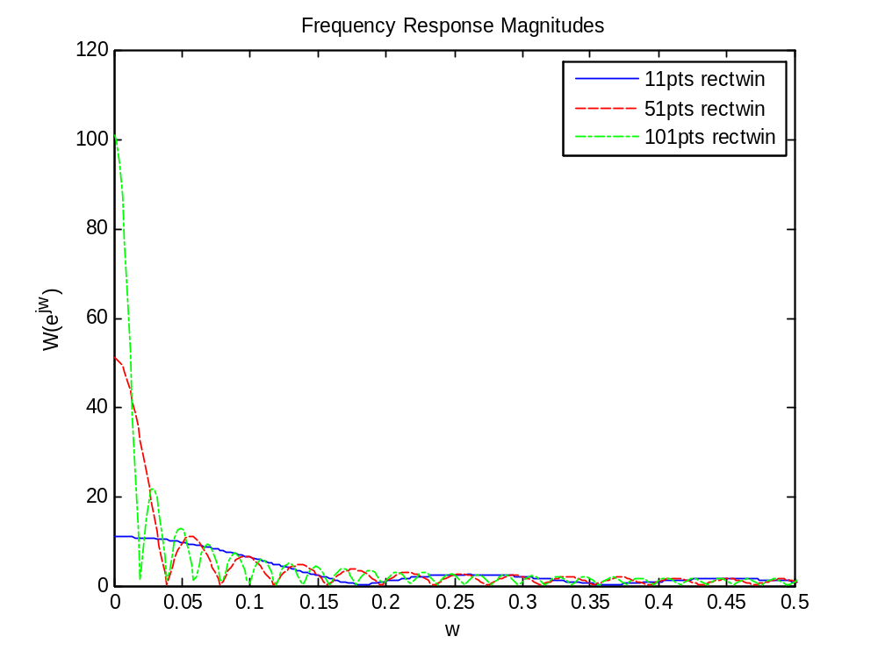
Each has its own window’s length, therefore their mainlobes are different. As we predicted in the previous part, as we increase the window’s length, the mainlobe decreases.
%---------------------------------------------------------
%% 2.c.i
%---------------------------------------------------------
wc = pi/3;
M = [5 25 50];
inc = 1;
for i=1:3
n1 = -M(i):inc:-inc;
n2 = inc:inc:M(i);
n0 = 0;
h_n1 = sin(wc*n1)./(pi*n1);
h_lhopital = wc*cos(wc*n0)/pi;
h_n2 = sin(wc*n2)./(pi*n2);
h = [h_n1 h_lhopital h_n2];
n = -M(i):inc:M(i);
figure(2);
subplot(3,1,i);
stem(n, h);
title(['h_',num2str(i),'[n] with ',num2str(M(i)*2+1),' pts']); xlabel('n'); ylabel('h[n]');
%---------------------------------------------------------
% 2.c.ii
%---------------------------------------------------------
figure(3);
subplot(3,1,i);
[H, w] = freqz(h, 1, 1024, 'whole');
plot(w/pi, abs(H));
title(['H_',num2str(i),' with ',num2str(M(i)*2+1),' pts']); xlabel('w'); ylabel('H(e^{jw})');
end

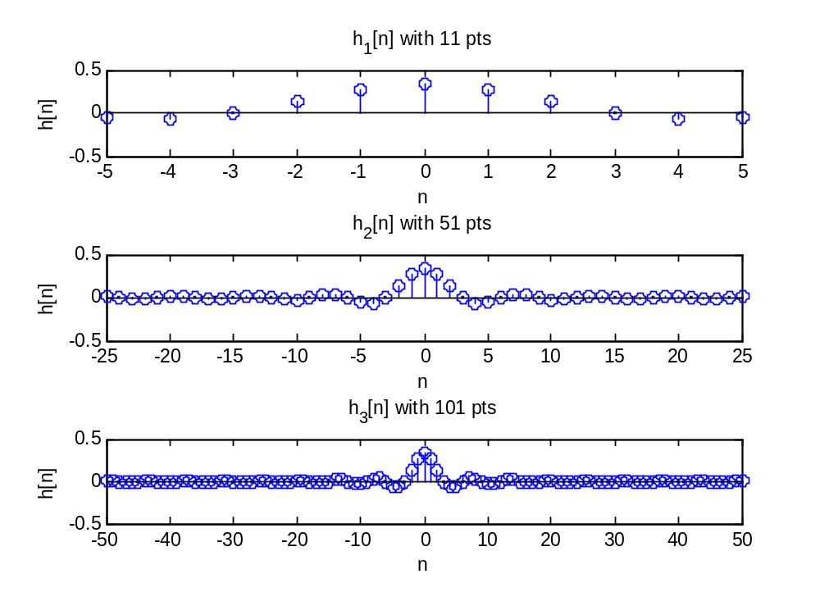
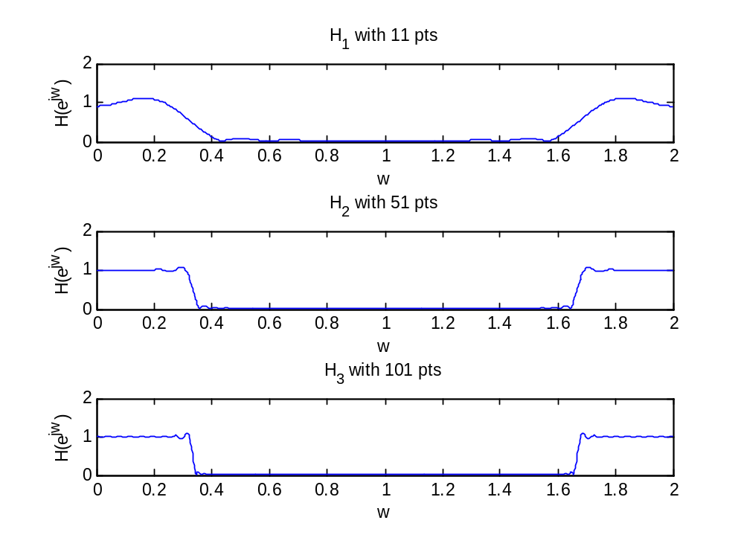
%---------------------------------------------------------
% 2.c.iii
%---------------------------------------------------------
These three frequency responses are different in the number of ripple. As we increase the window’s length, the number of ripple increases.
%---------------------------------------------------------
%% 2.d.i
%---------------------------------------------------------
n11 = -5:5;
wblkman11 = blackman(11);
n51 = -25:25;
wblkman51 = blackman(51);
n101 = -50:50;
wblkman101 = blackman(101);
figure(4);
subplot(3,1,1);
stem(n11, wblkman11);
title('Blackman window L=11');xlabel('n');ylabel('w');
subplot(3,1,2);
stem(n51, wblkman51);
title('Blackman window L=51');xlabel('n');ylabel('w');
subplot(3,1,3);
stem(n101, wblkman101);
title('Blackman window L=101');xlabel('n');ylabel('w');
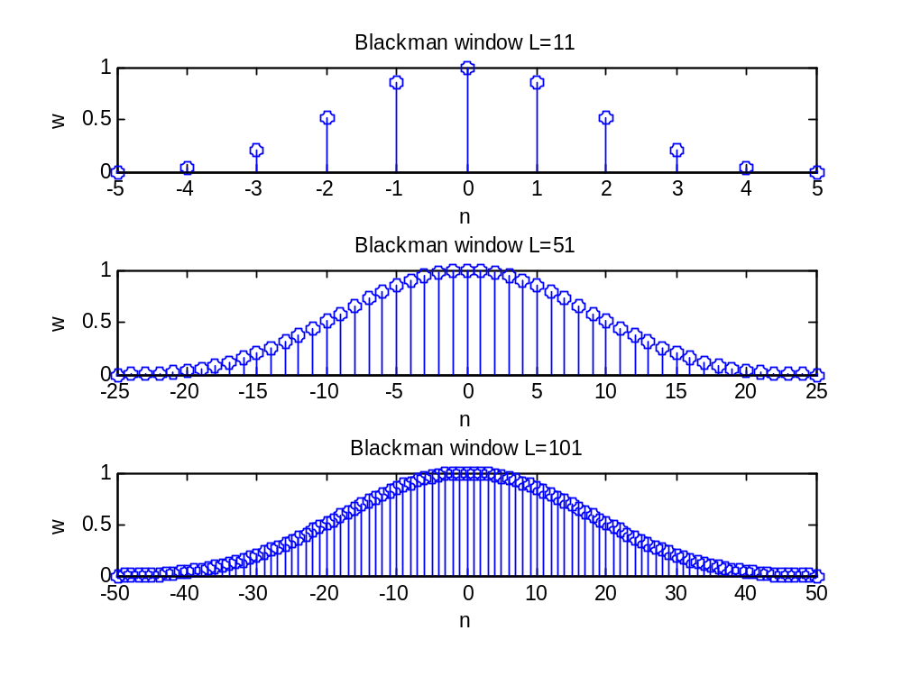
Blackman window looks like a sinc waveform with only mainlobe.
%---------------------------------------------------------
% 2.d.ii
%---------------------------------------------------------
[Wbm11, w11] = freqz(wblkman11, 1, 1024, 'whole');
[Wbm51, w51] = freqz(wblkman51, 1, 1024, 'whole');
[Wbm101, w101] = freqz(wblkman101, 1, 1024, 'whole');
figure(5);
subplot(3,1,1);
plot(w11/pi, 10*log10(abs(Wbm11)));
title('Blackman Freq. Resp. Magnitudes L=11'); xlabel('w'); ylabel('20log10(abs(W))');
subplot(3,1,2);
plot(w51/pi, 10*log10(abs(Wbm51)));
title('Blackman Freq. Resp. Magnitudes L=51'); xlabel('w'); ylabel('20log10(abs(W))');
subplot(3,1,3);
plot(w101/pi, 10*log10(abs(Wbm101)));
title('Blackman Freq. Resp. Magnitudes L=101'); xlabel('w'); ylabel('20log10(abs(W))');

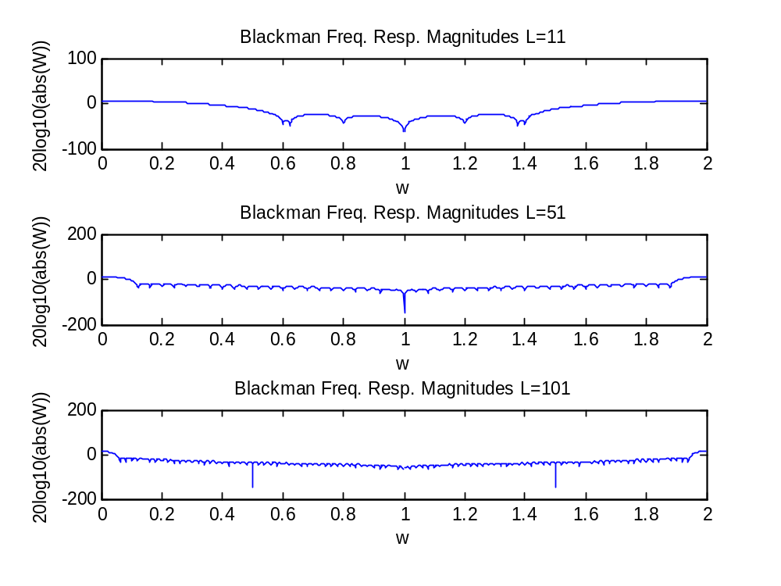
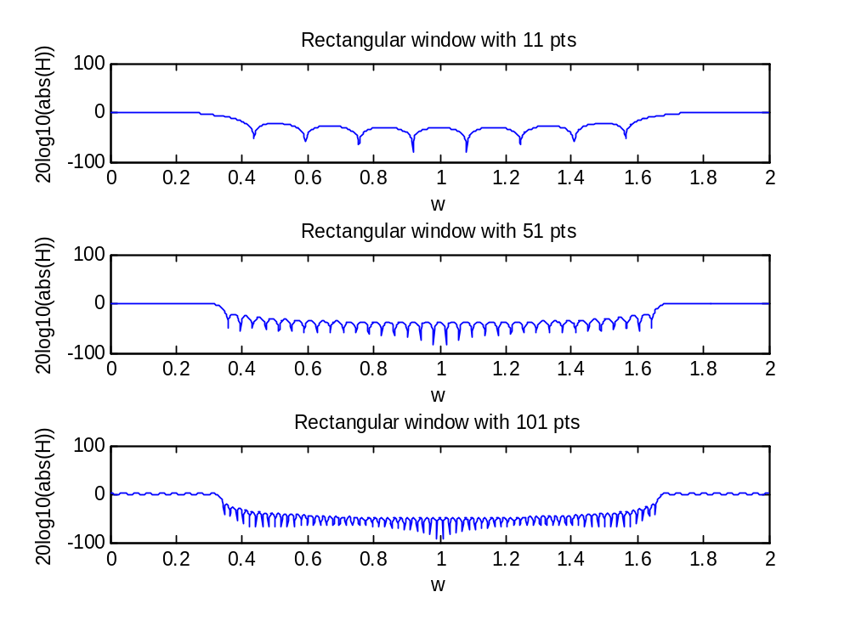
The blackman has lower ripple as compare to the rectangular.
%---------------------------------------------------------
%% 2.d.iii
%---------------------------------------------------------
wc = pi/3;
M = [5 25 50];
inc = 1;
for i=1:3
n1 = -M(i):inc:-inc;
n2 = inc:inc:M(i);
n0 = 0;
h_n1 = sin(wc*n1)./(pi*n1);
h_lhopital = wc*cos(wc*n0)/pi;
h_n2 = sin(wc*n2)./(pi*n2);
hlpf = [h_n1 h_lhopital h_n2];
n = [n1 n0 n2];
wbm = blackman(M(i)*2+1);
h = wbm'.*hlpf;
[H, w] = freqz(h, 1, 1024, 'whole');
subplot(3,1,i);
plot(w/pi, abs(H));
title(['Blackman H_',num2str(i),' with ',num2str(M(i)*2+1),' pts']); xlabel('w'); ylabel('H(e^{jw})');
end
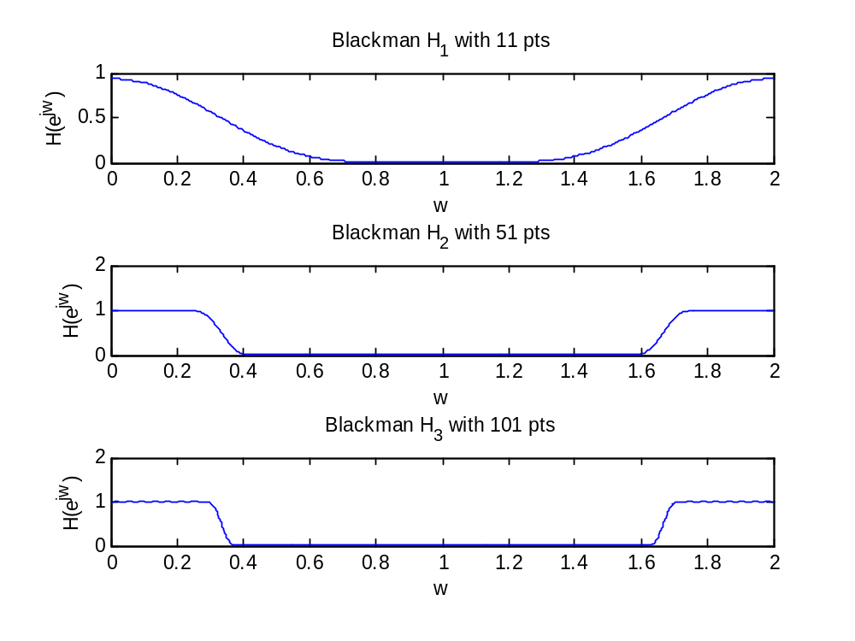
As compare to the rectangular, the blackman is smoothier and has less ripple.
%---------------------------------------------------------
% 2.e
%---------------------------------------------------------
function [h,n] = fir_lpf(wc, M, winfxn)
% Function to implement window design of lowpass filters
% wc : cutoff frequency
% M : integer that defines the length of the filter L = 2*M + 1
% winfxn : a string which contains the name of the window function to use
% example: @blackman, @hamming, ...
% notice the '@' right infront of each function name
n1 = -M:-1;
n2 = 1:M;
n0 = 0;
L = 2*M+1;
h_n1 = sin(wc*n1)./(pi*n1);
h_lhopital = wc*cos(wc*n0)/pi;
h_n2 = sin(wc*n2)./(pi*n2);
hlpf = [h_n1 h_lhopital h_n2];
n = [n1 n0 n2];
w = feval(winfxn, L);
h = w'.*hlpf;
plot(n, h);
%---------------------------------------------------------
%% 2.f
%---------------------------------------------------------
A few plots to prove this function work. The first three plots are from previous part. The following three plots are from our function fir_lpf().
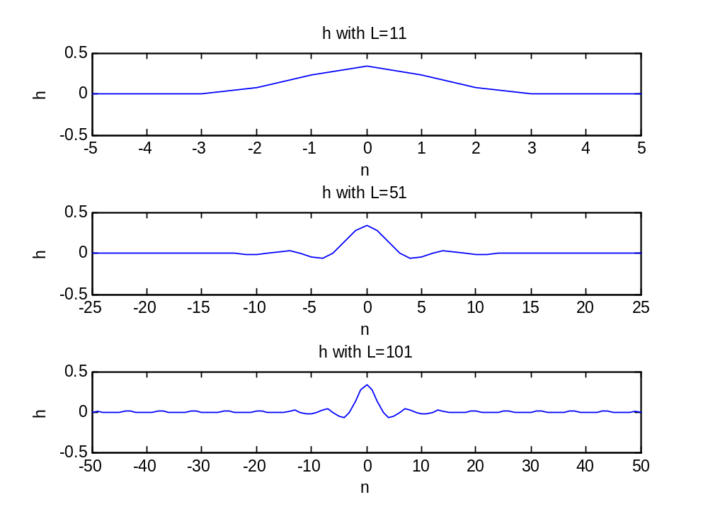
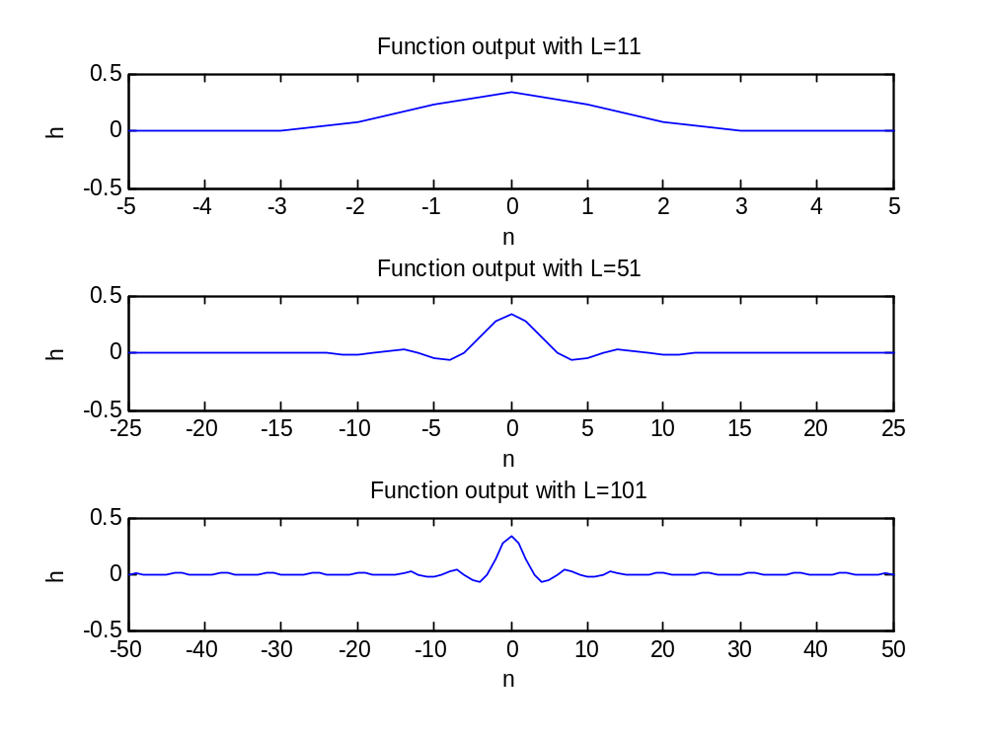
%---------------------------------------------------------
%% 3.c
%---------------------------------------------------------
wc = pi/4;
[h, n] = fir_lpf(wc, 50, @blackman);
hnew = h.*cos(pi*n);
[Hnew, w] = freqz(hnew, 1, 1024, 'whole');
plot(w/pi, abs(Hnew));
title('Freq. Resp.'); xlabel('w'); ylabel('H_{new}');

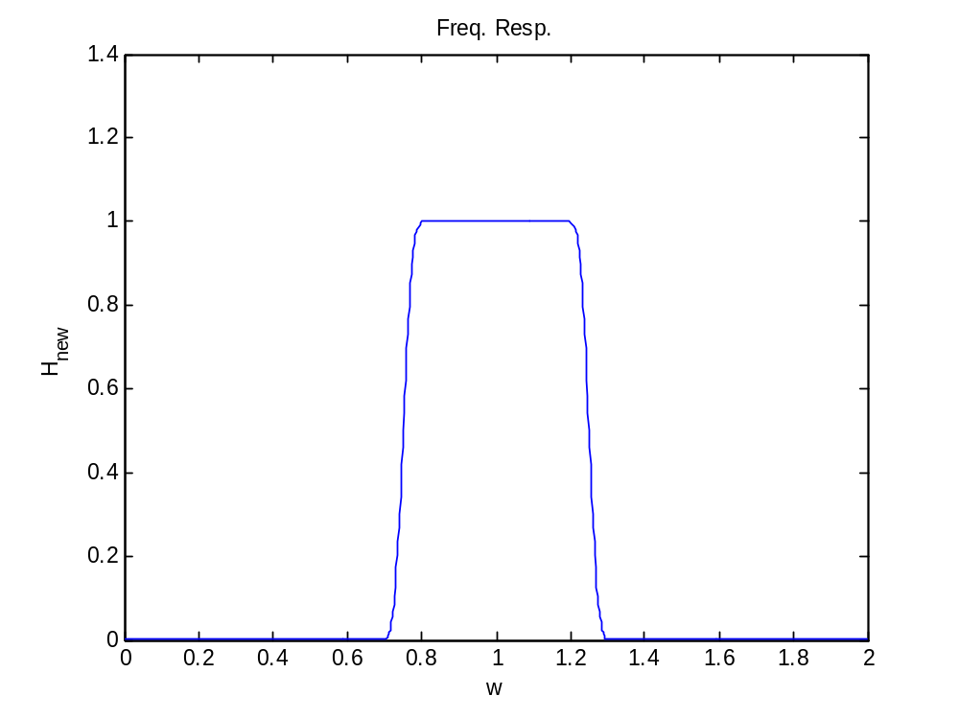
%---------------------------------------------------------
%% 3.d.i
%---------------------------------------------------------
n = -pi:0.01:pi;
Hbp = ((n>=-2*pi/3)&(n<=-pi/6))|((n>=pi/6)&(n<=2*pi/3));
plot(n, Hbp);
axis([-4 4 0 1.2]);
title('Bandpass Filter'); xlabel('w'); ylabel('Magnitude');
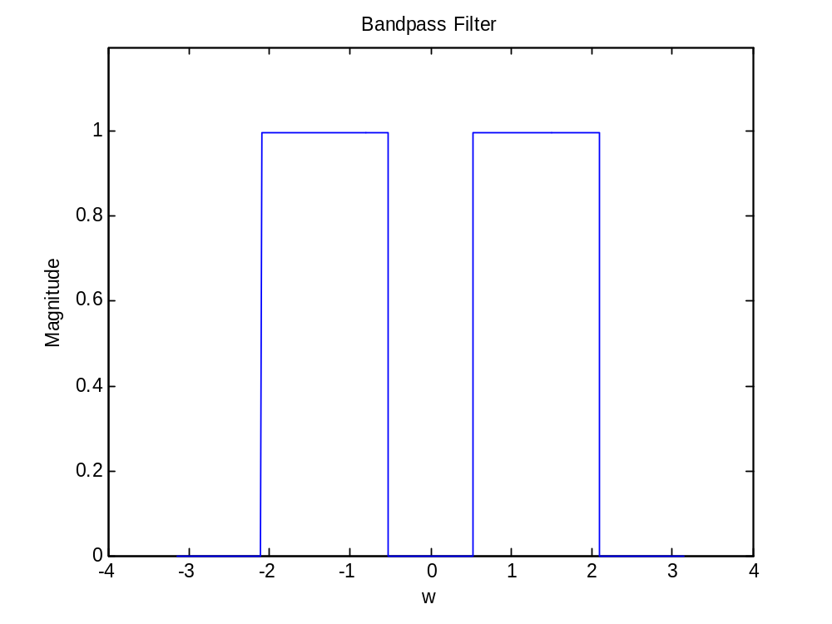
%---------------------------------------------------------
%% 3.d.ii & iii
%---------------------------------------------------------
wc = pi/4;
[h, n] = fir_lpf(wc, 50, @blackman);
hnew = h.*cos(5*pi*n/12)*2;
figure;
plot(n, hnew);
title('Impulse Resp.'); xlabel('n'); ylabel('h');
[Hnew, w] = freqz(hnew, 1, 1024, 'whole');
figure;
plot(w/pi, abs(Hnew));
title('Bandpass Filter'); xlabel('w'); ylabel('H_{new}');
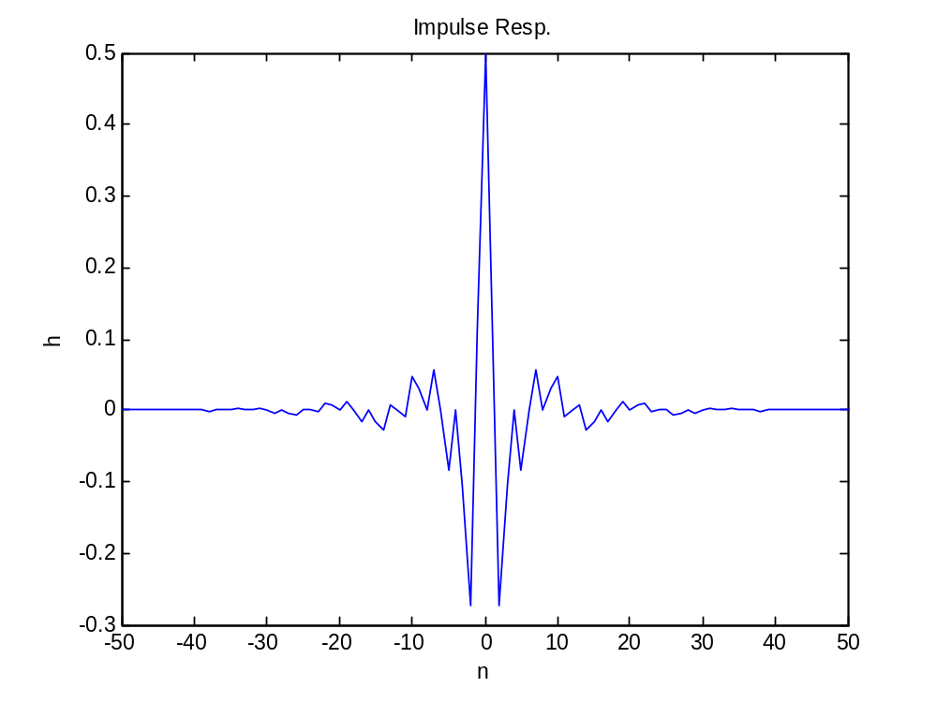
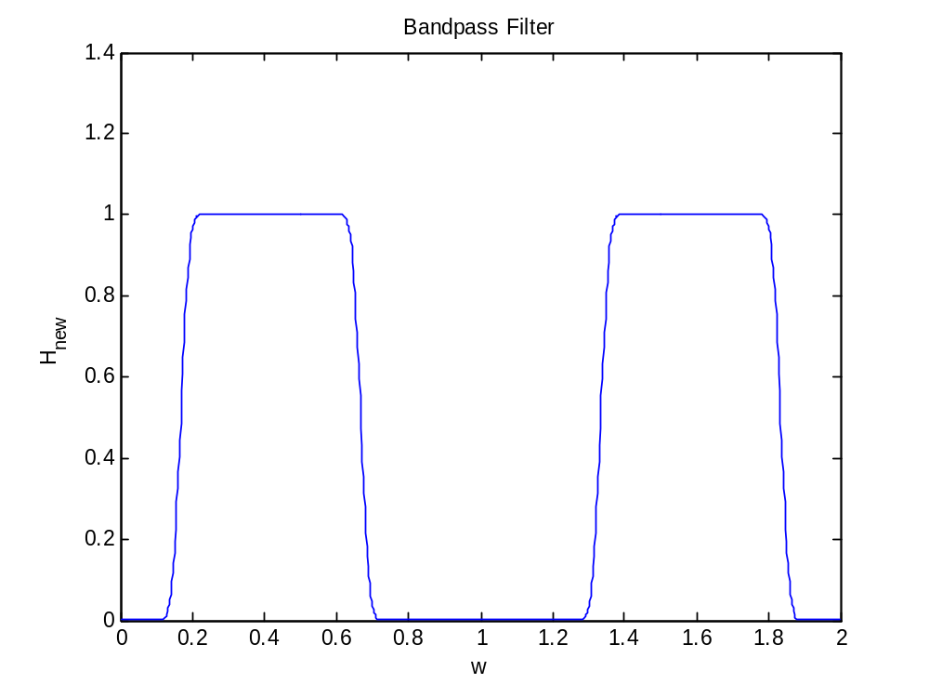
%---------------------------------------------------------
%% 4.1.b
%---------------------------------------------------------
wc = 0.304*pi;
fs = 22050;

[h1, n1] = fir_lpf(wc, 14, @rectwin);
[H1, f1] = freqz(h1, 1, 1024, 'whole', fs);
figure;
subplot(1,2,1);
plot(f1, abs(H1));grid;
axis([0 4500 0.8 1.2]);
title('rectwin'); xlabel('f'); ylabel('Magnitude');
subplot(1,2,2);
plot(f1, abs(H1));grid;
axis([3000 5000 0 0.3]);
title('rectwin'); xlabel('f'); ylabel('Magnitude');

[h2, n2] = fir_lpf(wc, 18, @bartlett);
[H2, f2] = freqz(h2, 1, 1024, 'whole', fs);
figure;
subplot(1,2,1);
plot(f2, abs(H2));grid;
axis([0 4500 0 1]);
title('bartlett'); xlabel('f'); ylabel('Magnitude');
subplot(1,2,2);
plot(f2, abs(H2));grid;
axis([3000 5500 0 0.3]);
title('bartlett'); xlabel('f'); ylabel('Magnitude');

[h3, n3] = fir_lpf(wc, 39, @hanning);
[H3, f3] = freqz(h3, 1, 1024, 'whole', fs);
figure;
subplot(1,2,1);
plot(f3, abs(H3));grid;
axis([0 4500 0.9 1.01]);
title('hanning'); xlabel('f'); ylabel('Magnitude');
subplot(1,2,2);
plot(f3, abs(H3));grid;
axis([3000 5000 0 0.1]);
title('hanning'); xlabel('f'); ylabel('Magnitude');

[h4, n4] = fir_lpf(wc, 49, @hamming);
[H4, f4] = freqz(h4, 1, 1024, 'whole', fs);
figure;
subplot(1,2,1);
plot(f4, abs(H4));grid;
axis([0 3100 0.99 1.01]);
title('hamming'); xlabel('f'); ylabel('Magnitude');
subplot(1,2,2);
plot(f4, abs(H4));grid;
axis([3100 4000 0 0.01]);
title('hamming'); xlabel('f'); ylabel('Magnitude');

[h5, n5] = fir_lpf(wc, 72, @blackman);
[H5, f5] = freqz(h5, 1, 1024, 'whole', fs);
figure;
subplot(1,2,1);
plot(f5, abs(H5));grid;
axis([0 3100 0.99 1.001]);
title('blackman'); xlabel('f'); ylabel('Magnitude');
subplot(1,2,2);
plot(f5, abs(H5));grid;
axis([3000 4000 0 0.01]);
title('blackman'); xlabel('f'); ylabel('Magnitude');
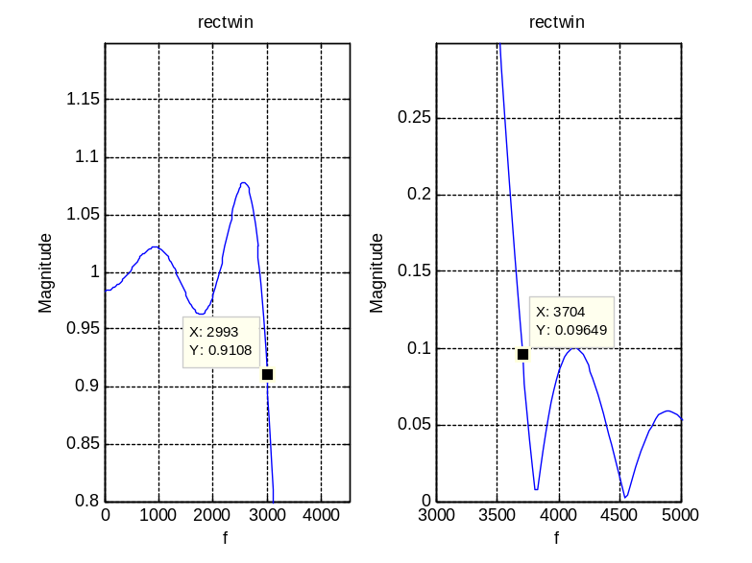
Delta1 = 0.0892 > 0.02. Delta2 = 0.09649 > 0.0032
Rectangular window does not meet the specification.
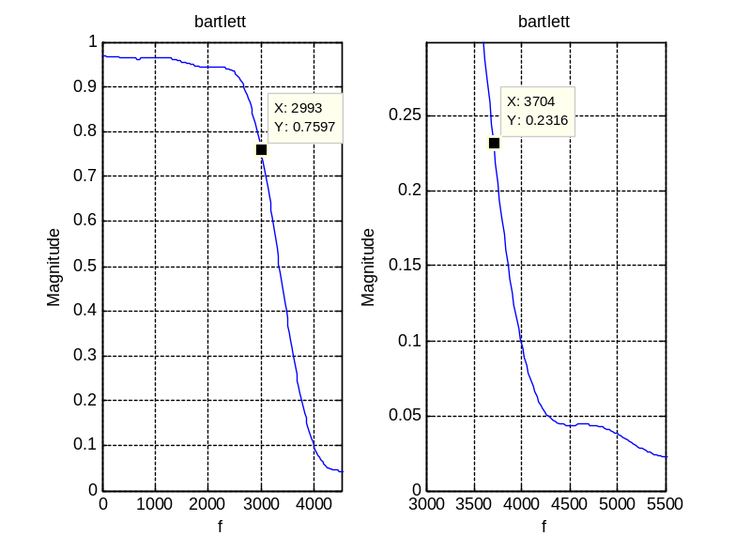
Delta1 = 0.2403 > 0.02. Delta2 = 0.2316 > 0.0032.
Bartlett window does not meet the specification.
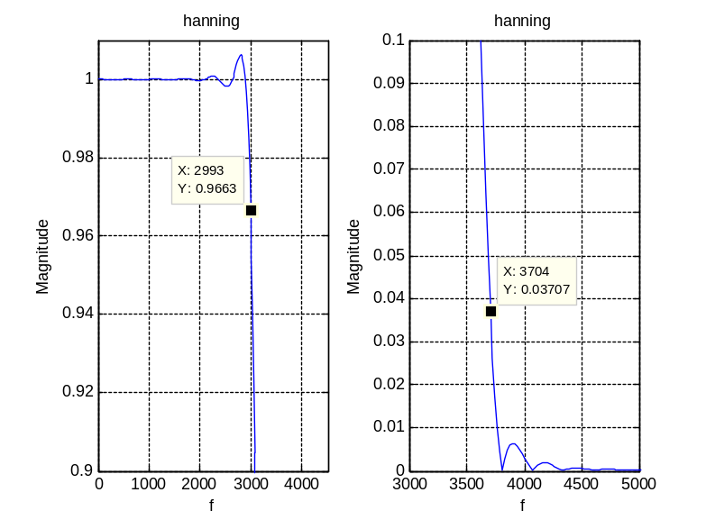
Delta1 = 0.0337 > 0.02. Delta2 = 0.3707 > 0.0032.
Hanning window does not meet the specification.
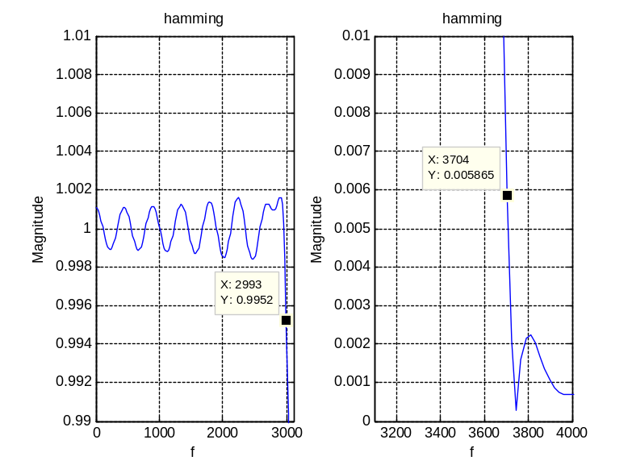
Delta1 = 0.0048 < 0.02. Delta2 = 0.005865 < 0.0032.
Hamming window meets the specification.
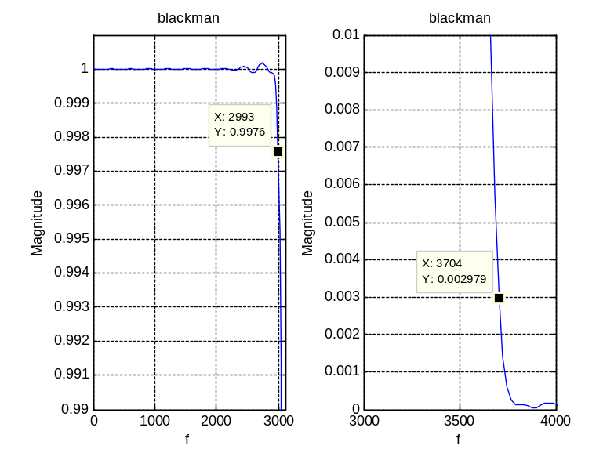
Delta1 = 0.0024 < 0.02. Delta2 = 0.002979 < 0.0032.
Blackman window meets the specification.
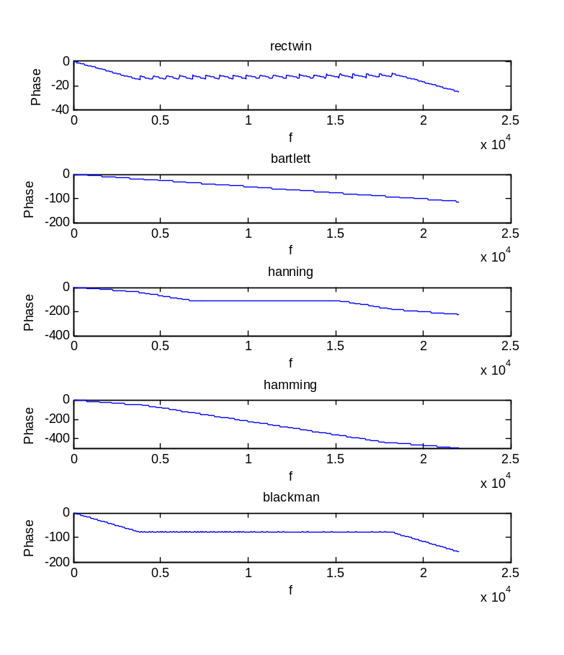
%---------------------------------------------------------
%% 4.1.c.i
%---------------------------------------------------------
load noisysig.mat;
soundsc(xnoisy, fs);
% It's a male cartoon voice but there were a lot of noise.
%---------------------------------------------------------
%% 4.1.c.ii
%---------------------------------------------------------
y1 = filter(h1, 1, xnoisy);
y2 = filter(h2, 1, xnoisy);
y3 = filter(h3, 1, xnoisy);
y4 = filter(h4, 1, xnoisy);
y5 = filter(h5, 1, xnoisy);
subplot(6,1,1);
plot(xnoisy);
title('Noisy signal'); xlabel('w'); ylabel('Magnitude');
subplot(6,1,2);
plot(y1);
title('Filtered w/ Rectangular'); xlabel('w'); ylabel('y1');
subplot(6,1,3);
plot(y2);
title('Filtered w/ Bartlett'); xlabel('w'); ylabel('y2');
subplot(6,1,4);
plot(y3);
title('Filtered w/ Hanning'); xlabel('w'); ylabel('y3');
subplot(6,1,5);
plot(y4);
title('Filtered w/ Hamming'); xlabel('w'); ylabel('y4');
subplot(6,1,6);
plot(y5);
title('Filtered w/ Blackman'); xlabel('w'); ylabel('y5');
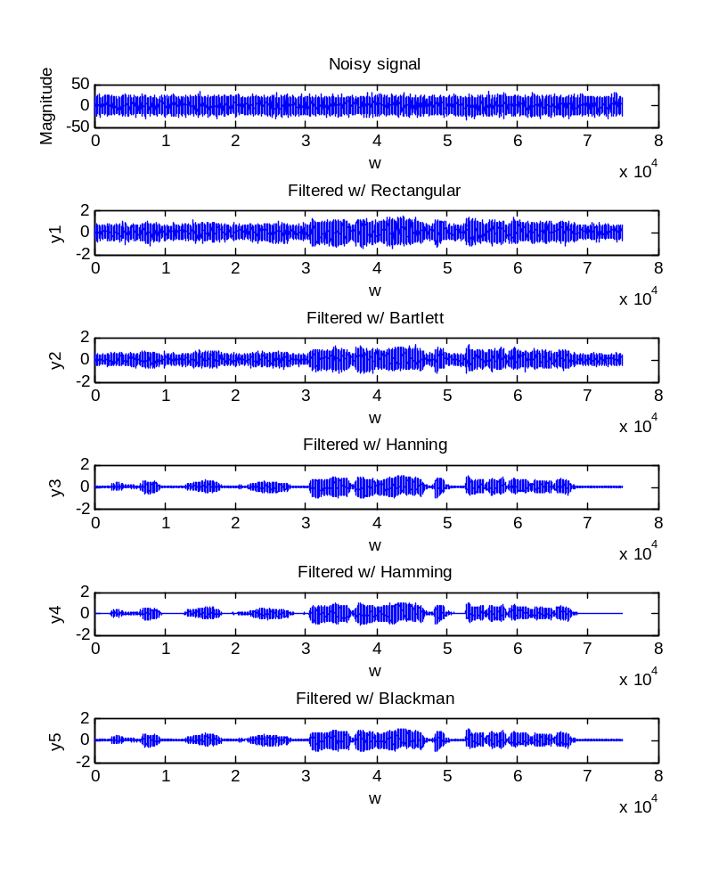
%---------------------------------------------------------
%% 4.1.c.iii
%---------------------------------------------------------
%% rectangular
soundsc(y1, fs); % still has lot of noise
%% bartlett
soundsc(y2, fs); % a bit less noise as compare to the rectangular
%% hanning
soundsc(y3, fs); % still noise but it's small
%% hamming
soundsc(y4, fs); % still noise but it's small
%% blackman
soundsc(y5, fs); % all noises are filtered
% It says: "in this town we obey the law of thermal dynamic"

